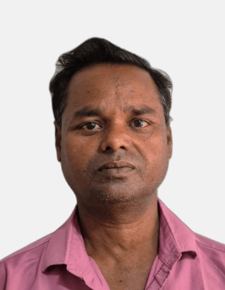**LOAN-CUM-USAGE AGREEMENT**  
  
**D.O. Number:** KEB28908  
**Customer Name:** Rasid Alam Ansari  
**Loan Amount:** ₹65,000  
**UID:** 6251 1231 4265  
**EMI Amount:** ₹5,000 per month  
**Loan Tenure:** 13 Months  
**1st EMI Due Date:** 05-07-2025

**TERMS & CONDITIONS**

1. **Repayment Obligation:**
   * The borrower agrees to repay the loan in 13 EMIs of ₹5,000 each.
   * EMIs must be paid on or before the 5th of every month without fail.
2. **Penalty on EMI Bounce:**
   * A penalty of ₹1,200 will be charged for any bounced EMI or late payment.
   * EMI default will result in **negative CIBIL reporting** which may impact future loan eligibility.
3. **Vehicle Repossession Clause:**
   * **If even a single EMI is missed**, the financier reserves the right to **repossess the vehicle** without any prior notice.
   * Borrower shall still be liable for remaining dues and legal recovery charges.
4. **No Sale or Transfer:**
   * The borrower shall not sell, transfer, or mortgage the financed vehicle until full repayment.
   * Attempting to do so may lead to **legal action under IPC Sections 420 & 406**.
5. **Ownership and Hypothecation:**
   * Until the loan is fully repaid, the vehicle shall remain hypothecated in favour of the financier (Minato Enterprise).
6. **Other Obligations:**
   * Borrower must use the vehicle for lawful commercial or personal purposes only.
   * In case of theft or accident, the borrower must inform the financier and lodge a police complaint immediately.

**EMI SCHEDULE**

| **EMI No.** | **Due Date** | **EMI Amount (₹)** |
| --- | --- | --- |
| 1 | 05-07-2025 | ₹5,000 |
| 2 | 05-08-2025 | ₹5,000 |
| 3 | 05-09-2025 | ₹5,000 |
| 4 | 05-10-2025 | ₹5,000 |
| 5 | 05-11-2025 | ₹5,000 |
| 6 | 05-12-2025 | ₹5,000 |
| 7 | 05-01-2026 | ₹5,000 |
| 8 | 05-02-2026 | ₹5,000 |
| 9 | 05-03-2026 | ₹5,000 |
| 10 | 05-04-2026 | ₹5,000 |
| 11 | 05-05-2026 | ₹5,000 |
| 12 | 05-06-2026 | ₹5,000 |
| 13 | 05-07-2026 | ₹5,000 |

**DECLARATION**

I, **Rasid Alam Ansari**, hereby declare that I have read and understood the terms of this agreement. I agree to abide by all conditions and accept legal action in case of any default.

**Customer Signature:** ______________________

**Date:** _______________

**Dealer Signature (Minato Enterprise):** ______________________

**Seal of Dealer:** MINATO ENTERPRISE